|  |
| --- |
| **National University of Computer and Emerging Sciences** |
| In Lab Exercise 5  “Aggregation And Nested Queries” |
|  |
| Database Systems |
| Spring 2018 |

Department of Computer Science

FAST-NU, Lahore, Pakistan

# Exercise

For this exercise use the following schema, the script to create this schema and populate data is given in Twitter.SQL file.

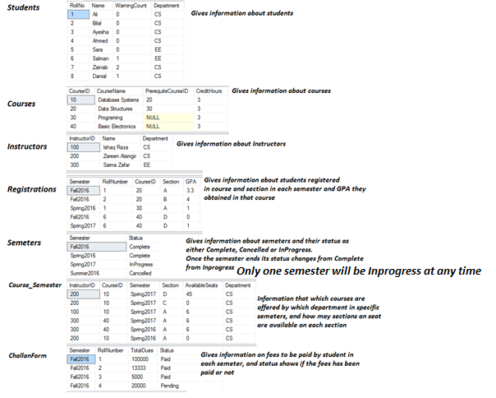

1. List all the students names and the number of subjects they have taken till now.
2. What is Maximum and Minimum and average and standard deviation of CGPA of the students? (Search Standard Dev function from help or internet)
3. Give name of the students who has earned most credit hours.
4. Give name of the student who has earned second highest credit hours.
5. List names of all the instructors who are taking the same subject in more than one sections
6. List total number of subjects per semester with their course id; list should be in order of semester name and then course id
7. List all the srudents that have never had a warning. Using Set operation
8. List all the srudents that have never had a warning. Using Exist Clause.
9. Show count of all the with with Name not starting from A
10. Show total dues submitted per semester.